Q1) call by value

#include<iostream>

using namespace std;

int swap(int a,int b);

int main(){

int x,y;

cin>>x>>y;

cout<<"\nx="<<x<<"y="<<y;

swap(x,y);

return 0;

}

int swap(int a,int b){

int c;

c=a;

a=b;

b=c;

cout<<"\na="<<a<<"b="<<b;

}

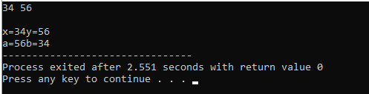

Q1) call by reference

#include<iostream>

using namespace std;

int swap(int \*a,int \*b);

int main(){

int x,y;

cin>>x>>y;

cout<<"\nx="<<x<<"y="<<y;

swap(x,y);

cout<<"\nx="<<x<<"y="<<y;

return 0;

}

int swap(int \*a,int \*b){

int \*c;

\*c=\*a;

\*a=\*b;

\*b=\*c;

}

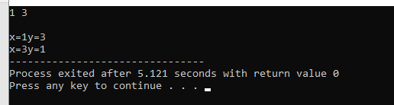

Q2) call by value

#include<iostream>

using namespace std;

int change(int a);

int main(){

int x;

cin>>x;

cout<<"\nx="<<x;

change(x);

return 0;

}

int change(int a){

a+=5;

cout<<"\na="<<a;

}

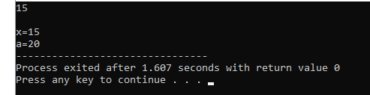

Q2) call by reference

#include<iostream>

using namespace std;

int change(int \*a);

int main(){

int x;

cin>>x;

cout<<"\nx="<<x;

change(&x);

cout<<"\nx="<<x;

return 0;

}

int change(int \*a){

\*a+=5;

}

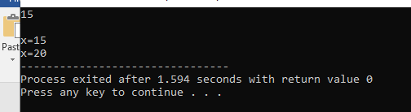

Q3)

#include<iostream>

using namespace std;

inline int add(int a,int b)

{

int c=a+b;

return c;

}

inline int sub(int a,int b)

{

int c=a-b;

return c;

}

inline int mul(int a,int b)

{

int c=a\*b;

return c;

}

inline float div(float a,float b)

{

float c=a/b;

return c;

}

int main()

{

int n;

float a,b,c;

cout<<"select operation\n";

cout<<"1.Addition\n 2.Subtraction\n 3.Multiplication\n 4. Division\n";

cin>>n;

switch(n)

{

case 1:

cout<<"enter the values of a & b\n";

cin>>a>>b;

c=add(a,b);

cout<<"sum="<<c;

break;

case 2:

cout<<"enter the values of a & b\n";

cin>>a>>b;

c=sub(a,b);

cout<<"difference"<<c;

break;

case 3:

cout<<"enter the values of a & b\n";

cin>>a>>b;

c=mul(a,b);

cout<<"product="<<c;

break;

case 4:

cout<<"enter the values of a & b\n";

cin>>a>>b;

c=div(a,b);

cout<<"quotient"<<c;

break;

default:

cout<<"enter correct operation";

}

return 0;

}

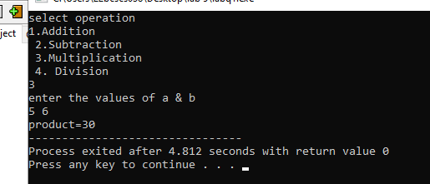

Q4)

#include<iostream>

using namespace std;

void area(int a)

{

int square=a\*a;

cout<<"The Area Of Square Value is:"<<square<<endl;

}

void area(int l,int b)

{

int rectangle=l\*b;

cout<<" The Area Of The Rectangle Value is:"<<rectangle<<endl;

}

void area(float r)

{

float circle=3.14\*r\*r;

cout<<"The Area of The Circle Value is:"<<circle<<endl;

}

void area (float le,float br)

{

float triangle=0.4\*le\*br;

cout<<" The Area Of the triangle value is:"<<triangle<<endl;

}

int main()

{

int a,b,l;

float r,le,br;

cout<<"AREA OF SHAPES USING FUNCTION OVERLOADING"<<endl;

cout<<"Enter one value for Square:";

cin>>a;

cout<<endl;

cout<<"Enter two value for Rectangle:";

cin>>b>>l;

cout<<endl;

cout<<"Enter one value for Circle:";

cin>>r;

cout<<endl;

cout<<"Enter two values for triangle:";

cin>>le>>br;

cout<<endl;

area(a);

area(l,b);

area(r);

area(le,br);

return 0;

}

